DAVID SIBANDA 25/SCA/BCDS/022

1.Write a program to perform the operations of the linked list: - Insertion
- Deletion
- Display

#include <stdio.h>

#define MAX 100

int arr[MAX];
int size = 0;

void display() {
if (size == 0) {
printf("Array is empty.\n");
return;
}
printf("Array elements: ");
for (int i = 0; i < size; i++) {
printf("%d ", arr[i]);
}
printf("\n");
}

void insert(int element, int pos) {
if (size >= MAX) {
printf("Array is full. Cannot insert.\n");
return;
}
if (pos < 0 || pos > size) {
printf("Invalid position.\n");
return;
}
for (int i = size; i > pos; i--) {
arr[i] = arr[i - 1];
}
arr[pos] = element;
size++;
printf("Inserted %d at position %d.\n", element, pos);
}

void delete(int pos) {
if (size == 0) {
printf("Array is empty. Cannot delete.\n");
return;
}
if (pos < 0 || pos >= size) {
printf("Invalid position.\n");
return;
}
printf("Deleted %d from position %d.\n", arr[pos], pos);
for (int i = pos; i < size - 1; i++) {
arr[i] = arr[i + 1];
}
size--;
}

int main() {
int choice, element, pos;

while (1) {
printf("\nArray Operations Menu:\n");
printf("1. Insert\n");
printf("2. Delete\n");
printf("3. Display\n");
printf("4. Exit\n");
printf("Enter your choice: ");
scanf("%d", &choice);

switch (choice) {
case 1:
printf("Enter element to insert: ");
scanf("%d", &element);
printf("Enter position (0 to %d): ", size);
scanf("%d", &pos);
insert(element, pos);
break;
case 2:
printf("Enter position to delete (0 to %d): ", size - 1);
scanf("%d", &pos);
delete(pos);
break;
case 3:
display();
break;
case 4:
return 0;
default:
printf("Invalid choice.\n");
}
}
}

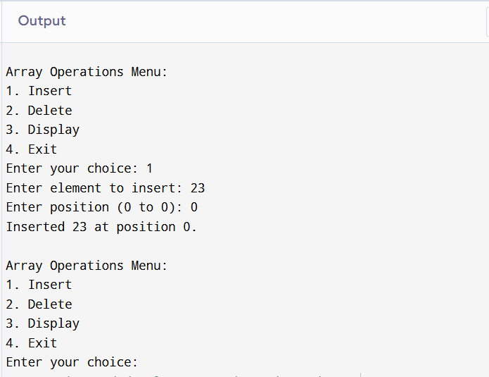

2.Write a program to find the arithmetic operations on matrices:
- Sum and Subtraction
- Product of 2 matrices
- Transpose of a matrix

#include <stdio.h>

#define MAX 10
void inputMatrix(int mat[MAX][MAX], int rows, int cols) {
printf("Enter elements of matrix (%d x %d):\n", rows, cols);
for (int i = 0; i < rows; i++) {
for (int j = 0; j < cols; j++) {
scanf("%d", &mat[i][j]);
}
}
}
void displayMatrix(int mat[MAX][MAX], int rows, int cols) {
for (int i = 0; i < rows; i++) {
for (int j = 0; j < cols; j++) {
printf("%d ", mat[i][j]);
}
printf("\n");
}
}
void addMatrix(int a[MAX][MAX], int b[MAX][MAX], int rows, int cols) {
int sum[MAX][MAX];
for (int i = 0; i < rows; i++) {
for (int j = 0; j < cols; j++) {
sum[i][j] = a[i][j] + b[i][j];
}
}
printf("Sum of matrices:\n");
displayMatrix(sum, rows, cols);
}
void subtractMatrix(int a[MAX][MAX], int b[MAX][MAX], int rows, int cols) {
int diff[MAX][MAX];
for (int i = 0; i < rows; i++) {
for (int j = 0; j < cols; j++) {
diff[i][j] = a[i][j] - b[i][j];
}
}
printf("Difference of matrices:\n");
displayMatrix(diff, rows, cols);
}
void multiplyMatrix(int a[MAX][MAX], int b[MAX][MAX], int r1, int c1, int r2, int c2) {
if (c1 != r2) {
printf("Matrix multiplication not possible (columns of A != rows of B).\n");
return;
}
int product[MAX][MAX];
for (int i = 0; i < r1; i++) {
for (int j = 0; j < c2; j++) {
product[i][j] = 0;
for (int k = 0; k < c1; k++) {
product[i][j] += a[i][k] * b[k][j];
}
}
}
printf("Product of matrices:\n");
displayMatrix(product, r1, c2);
}
void transposeMatrix(int mat[MAX][MAX], int rows, int cols) {
int trans[MAX][MAX];
for (int i = 0; i < rows; i++) {
for (int j = 0; j < cols; j++) {
trans[j][i] = mat[i][j];
}
}
printf("Transpose of matrix:\n");
displayMatrix(trans, cols, rows);
}

int main() {
int a[MAX][MAX], b[MAX][MAX];
int r1, c1, r2, c2;

printf("Enter rows and columns of Matrix A: ");
scanf("%d %d", &r1, &c1);
inputMatrix(a, r1, c1);

printf("Enter rows and columns of Matrix B: ");
scanf("%d %d", &r2, &c2);
inputMatrix(b, r2, c2);

printf("\nMatrix A:\n");
displayMatrix(a, r1, c1);

printf("\nMatrix B:\n");
displayMatrix(b, r2, c2);

if (r1 == r2 && c1 == c2) {
addMatrix(a, b, r1, c1);
subtractMatrix(a, b, r1, c1);
} else {
printf("Addition and subtraction not possible (different dimensions).\n");
}

multiplyMatrix(a, b, r1, c1, r2, c2);

printf("\nTranspose of Matrix A:\n");
transposeMatrix(a, r1, c1);

printf("\nTranspose of Matrix B:\n");
transposeMatrix(b, r2, c2);

return 0;
}

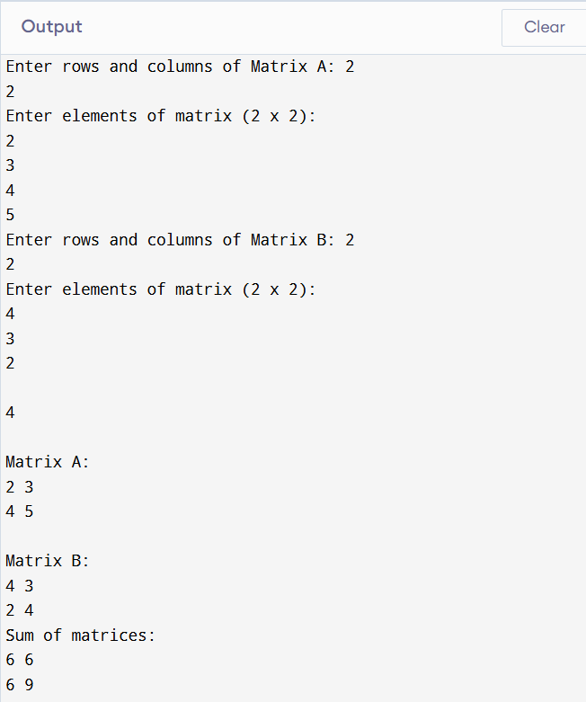

3.Write a Program to sort the list using:
- Bubble Sort
- Quick Sort
- Insertion sort
- Merge Sort
- Heap Sort Also, find the comparison on the basis of time complexity

#include <stdio.h>

#define MAX 100

// Bubble Sort
void bubbleSort(int arr[], int n) {
for (int i = 0; i < n-1; i++) {
for (int j = 0; j < n-i-1; j++) {
if (arr[j] > arr[j+1]) {
int temp = arr[j];
arr[j] = arr[j+1];
arr[j+1] = temp;
}
}
}
}

// Insertion Sort
void insertionSort(int arr[], int n) {
for (int i = 1; i < n; i++) {
int key = arr[i];
int j = i - 1;
while (j >= 0 && arr[j] > key) {
arr[j+1] = arr[j];
j--;
}
arr[j+1] = key;
}
}

// Quick Sort
int partition(int arr[], int low, int high) {
int pivot = arr[high];
int i = low - 1;
for (int j = low; j < high; j++) {
if (arr[j] < pivot) {
i++;
int temp = arr[i]; arr[i] = arr[j]; arr[j] = temp;
}
}
int temp = arr[i+1]; arr[i+1] = arr[high]; arr[high] = temp;
return i+1;
}

void quickSort(int arr[], int low, int high) {
if (low < high) {
int pi = partition(arr, low, high);
quickSort(arr, low, pi-1);
quickSort(arr, pi+1, high);
}
}

// Merge Sort
void merge(int arr[], int l, int m, int r) {
int n1 = m - l + 1, n2 = r - m;
int L[n1], R[n2];
for (int i = 0; i < n1; i++) L[i] = arr[l+i];
for (int j = 0; j < n2; j++) R[j] = arr[m+1+j];

int i=0, j=0, k=l;
while (i<n1 && j<n2) {
if (L[i] <= R[j]) arr[k++] = L[i++];
else arr[k++] = R[j++];
}
while (i<n1) arr[k++] = L[i++];
while (j<n2) arr[k++] = R[j++];
}

void mergeSort(int arr[], int l, int r) {
if (l < r) {
int m = l + (r-l)/2;
mergeSort(arr, l, m);
mergeSort(arr, m+1, r);
merge(arr, l, m, r);
}
}

// Heap Sort
void heapify(int arr[], int n, int i) {
int largest = i;
int l = 2*i+1, r = 2*i+2;
if (l < n && arr[l] > arr[largest]) largest = l;
if (r < n && arr[r] > arr[largest]) largest = r;
if (largest != i) {
int temp = arr[i]; arr[i] = arr[largest]; arr[largest] = temp;
heapify(arr, n, largest);
}
}

void heapSort(int arr[], int n) {
for (int i = n/2-1; i >= 0; i--) heapify(arr, n, i);
for (int i = n-1; i > 0; i--) {
int temp = arr[0]; arr[0] = arr[i]; arr[i] = temp;
heapify(arr, i, 0);
}
}

// Display array
void display(int arr[], int n) {
for (int i = 0; i < n; i++) printf("%d ", arr[i]);
printf("\n");
}

int main() {
int arr[MAX], n;
printf("Enter number of elements: ");
scanf("%d", &n);
printf("Enter elements: ");
for (int i = 0; i < n; i++) scanf("%d", &arr[i]);

int temp[MAX];

// Bubble Sort
for (int i=0;i<n;i++) temp[i]=arr[i];
bubbleSort(temp, n);
printf("Bubble Sort: "); display(temp, n);

// Insertion Sort
for (int i=0;i<n;i++) temp[i]=arr[i];
insertionSort(temp, n);
printf("Insertion Sort: "); display(temp, n);

// Quick Sort
for (int i=0;i<n;i++) temp[i]=arr[i];
quickSort(temp, 0, n-1);
printf("Quick Sort: "); display(temp, n);

// Merge Sort
for (int i=0;i<n;i++) temp[i]=arr[i];
mergeSort(temp, 0, n-1);
printf("Merge Sort: "); display(temp, n);

// Heap Sort
for (int i=0;i<n;i++) temp[i]=arr[i];
heapSort(temp, n);
printf("Heap Sort: "); display(temp, n);

return 0;
}

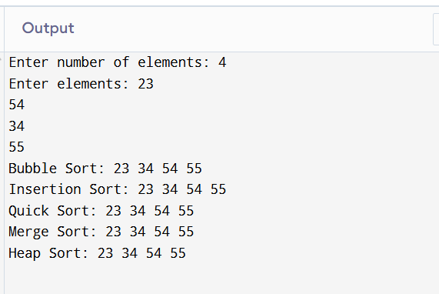

4.Write a program to search the element using:
- Linear Search
- Binary Search Also, find the comparison on the basis of time complexity

#include <stdio.h>

// Linear Search
int linearSearch(int arr[], int n, int key) {
for (int i = 0; i < n; i++) {
if (arr[i] == key)
return i; // return index if found
}
return -1; // not found
}

// Binary Search (array must be sorted)
int binarySearch(int arr[], int low, int high, int key) {
while (low <= high) {
int mid = low + (high - low) / 2;
if (arr[mid] == key)
return mid;
else if (arr[mid] < key)
low = mid + 1;
else
high = mid - 1;
}
return -1; // not found
}

int main() {
int arr[100], n, key, choice, result;

printf("Enter number of elements: ");
scanf("%d", &n);

printf("Enter elements (sorted for binary search): ");
for (int i = 0; i < n; i++) {
scanf("%d", &arr[i]);
}

printf("Enter element to search: ");
scanf("%d", &key);

printf("\nChoose Search Method:\n");
printf("1. Linear Search\n");
printf("2. Binary Search\n");
scanf("%d", &choice);

if (choice == 1) {
result = linearSearch(arr, n, key);
if (result != -1)
printf("Element found at index %d using Linear Search.\n", result);
else
printf("Element not found using Linear Search.\n");
} else if (choice == 2) {
result = binarySearch(arr, 0, n-1, key);
if (result != -1)
printf("Element found at index %d using Binary Search.\n", result);
else
printf("Element not found using Binary Search.\n");
} else {
printf("Invalid choice.\n");
}

return 0;
}

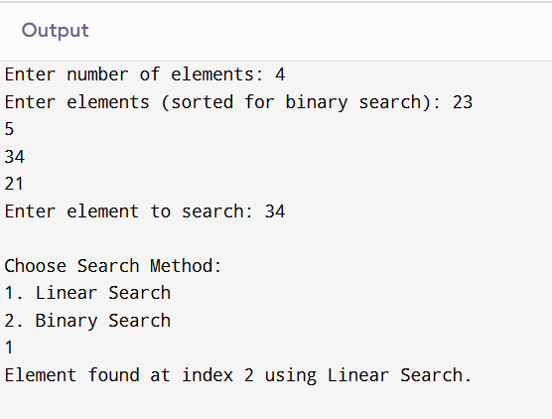

5.Write a program to perform all operations:
- For the Stack using an Array.
- For the Queue using an Array.
- For the Circular Queue using an Array.

#include <stdio.h>
#define MAX 5

// ---------- STACK ----------
int stack[MAX], top = -1;

void push(int x) {
if (top == MAX - 1) {
printf("Stack Overflow\n");
return;
}
stack[++top] = x;
printf("%d pushed to stack\n", x);
}

void pop() {
if (top == -1) {
printf("Stack Underflow\n");
return;
}
printf("%d popped from stack\n", stack[top--]);
}

void displayStack() {
if (top == -1) {
printf("Stack is empty\n");
return;
}
printf("Stack elements: ");
for (int i = 0; i <= top; i++) {
printf("%d ", stack[i]);
}
printf("\n");
}

// ---------- QUEUE ----------
int queue[MAX], front = -1, rear = -1;

void enqueue(int x) {
if (rear == MAX - 1) {
printf("Queue Overflow\n");
return;
}
if (front == -1) front = 0;
queue[++rear] = x;
printf("%d enqueued to queue\n", x);
}

void dequeue() {
if (front == -1 || front > rear) {
printf("Queue Underflow\n");
return;
}
printf("%d dequeued from queue\n", queue[front++]);
}

void displayQueue() {
if (front == -1 || front > rear) {
printf("Queue is empty\n");
return;
}
printf("Queue elements: ");
for (int i = front; i <= rear; i++) {
printf("%d ", queue[i]);
}
printf("\n");
}

// ---------- CIRCULAR QUEUE ----------
int cqueue[MAX], cfront = -1, crear = -1;

void cenqueue(int x) {
if ((cfront == 0 && crear == MAX - 1) || (crear + 1 == cfront)) {
printf("Circular Queue Overflow\n");
return;
}
if (cfront == -1) cfront = 0;
crear = (crear + 1) % MAX;
cqueue[crear] = x;
printf("%d enqueued to circular queue\n", x);
}

void cdequeue() {
if (cfront == -1) {
printf("Circular Queue Underflow\n");
return;
}
printf("%d dequeued from circular queue\n", cqueue[cfront]);
if (cfront == crear) {
cfront = crear = -1;
} else {
cfront = (cfront + 1) % MAX;
}
}

void displayCQueue() {
if (cfront == -1) {
printf("Circular Queue is empty\n");
return;
}
printf("Circular Queue elements: ");
int i = cfront;
while (1) {
printf("%d ", cqueue[i]);
if (i == crear) break;
i = (i + 1) % MAX;
}
printf("\n");
}

// ---------- MAIN ----------
int main() {
int choice, x;
while (1) {
printf("\nMenu:\n");
printf("1. Push (Stack)\n2. Pop (Stack)\n3. Display Stack\n");
printf("4. Enqueue (Queue)\n5. Dequeue (Queue)\n6. Display Queue\n");
printf("7. Enqueue (Circular Queue)\n8. Dequeue (Circular Queue)\n9. Display Circular Queue\n");
printf("10. Exit\n");
printf("Enter choice: ");
scanf("%d", &choice);

switch (choice) {
case 1: printf("Enter value: "); scanf("%d", &x); push(x); break;
case 2: pop(); break;
case 3: displayStack(); break;
case 4: printf("Enter value: "); scanf("%d", &x); enqueue(x); break;
case 5: dequeue(); break;
case 6: displayQueue(); break;
case 7: printf("Enter value: "); scanf("%d", &x); cenqueue(x); break;
case 8: cdequeue(); break;
case 9: displayCQueue(); break;
case 10: return 0;
default: printf("Invalid choice\n");
}
}
}

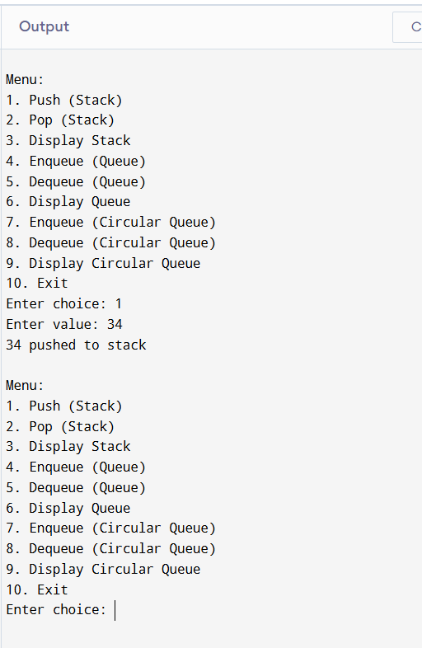

- Write a program to evaluate the Postfix Notation.

#include <stdio.h>
#include <ctype.h> // for isdigit()
#include <string.h>

#define MAX 100

int stack[MAX];
int top = -1;

// Push function
void push(int x) {
if (top == MAX - 1) {
printf("Stack Overflow\n");
return;
}
stack[++top] = x;
}

// Pop function
int pop() {
if (top == -1) {
printf("Stack Underflow\n");
return -1;
}
return stack[top--];
}

// Evaluate Postfix Expression
int evaluatePostfix(char* exp) {
int i;
for (i = 0; exp[i] != '\0'; i++) {
// If operand, push to stack
if (isdigit(exp[i])) {
push(exp[i] - '0'); // convert char to int
}
// If operator, pop two operands and apply
else {
int val2 = pop();
int val1 = pop();
switch (exp[i]) {
case '+': push(val1 + val2); break;
case '-': push(val1 - val2); break;
case '*': push(val1 * val2); break;
case '/': push(val1 / val2); break;
default: printf("Invalid operator %c\n", exp[i]);
}
}
}
return pop();
}

int main() {
char exp[MAX];
printf("Enter a postfix expression (single-digit operands): ");
scanf("%s", exp);

int result = evaluatePostfix(exp);
printf("Result of postfix evaluation: %d\n", result);

return 0;
}

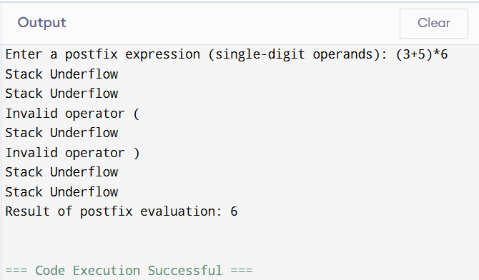

- Write a program to convert infix notation into Postfix Notation.
#include <stdio.h>
#include <ctype.h> // for isalnum()
#include <string.h>
#define MAX 100
char stack[MAX];
int top = -1;

// Push to stack
void push(char c) {
if (top == MAX - 1) {
printf("Stack Overflow\n");
return;
}
stack[++top] = c;
}

// Pop from stack
char pop() {
if (top == -1) {
return -1;
}
return stack[top--];
}

// Peek top of stack
char peek() {
if (top == -1) return -1;
return stack[top];
}

// Operator precedence
int precedence(char op) {
if (op == '^') return 3;
if (op == '*' || op == '/') return 2;
if (op == '+' || op == '-') return 1;
return 0;
}

// Convert Infix to Postfix
void infixToPostfix(char* infix, char* postfix) {
int i, k = 0;
for (i = 0; infix[i] != '\0'; i++) {
char c = infix[i];

// If operand, add to postfix
if (isalnum(c)) {
postfix[k++] = c;
}
// If '(', push to stack
else if (c == '(') {
push(c);
}
// If ')', pop until '('
else if (c == ')') {
while (top != -1 && peek() != '(') {
postfix[k++] = pop();
}
pop(); // remove '('
}
// If operator
else {
while (top != -1 && precedence(peek()) >= precedence(c)) {
postfix[k++] = pop();
}
push(c);
}
}
// Pop remaining operators
while (top != -1) {
postfix[k++] = pop();
}
postfix[k] = '\0';
}
int main() {
char infix[MAX], postfix[MAX];
printf("Enter an infix expression: ");
scanf("%s", infix);
infixToPostfix(infix, postfix);
printf("Postfix expression: %s\n", postfix);
return 0;
}

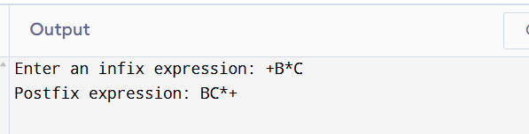

8.Write a program to perform the operations of the linked list:
- Insertion
- Deletion
- Display

#include <stdio.h>
#include <stdlib.h>

// Node structure
struct Node {
int data;
struct Node* next;
};

struct Node* head = NULL;

// Function to insert at the end
void insert(int value) {
struct Node* newNode = (struct Node*)malloc(sizeof(struct Node));
newNode->data = value;
newNode->next = NULL;

if (head == NULL) {
head = newNode;
} else {
struct Node* temp = head;
while (temp->next != NULL) {
temp = temp->next;
}
temp->next = newNode;
}
printf("%d inserted into the list.\n", value);
}

// Function to delete a node by value
void delete(int value) {
if (head == NULL) {
printf("List is empty. Cannot delete.\n");
return;
}

struct Node* temp = head;
struct Node* prev = NULL;

// If head node itself holds the value
if (temp != NULL && temp->data == value) {
head = temp->next;
free(temp);
printf("%d deleted from the list.\n", value);
return;
}

// Search for the value
while (temp != NULL && temp->data != value) {
prev = temp;
temp = temp->next;
}

// If value not found
if (temp == NULL) {
printf("%d not found in the list.\n", value);
return;
}

prev->next = temp->next;
free(temp);
printf("%d deleted from the list.\n", value);
}

// Function to display the list
void display() {
if (head == NULL) {
printf("List is empty.\n");
return;
}
struct Node* temp = head;
printf("Linked List: ");
while (temp != NULL) {
printf("%d -> ", temp->data);
temp = temp->next;
}
printf("NULL\n");
}

int main() {
int choice, value;

while (1) {
printf("\nMenu:\n");
printf("1. Insert\n2. Delete\n3. Display\n4. Exit\n");
printf("Enter your choice: ");
scanf("%d", &choice);

switch (choice) {
case 1:
printf("Enter value to insert: ");
scanf("%d", &value);
insert(value);
break;
case 2:
printf("Enter value to delete: ");
scanf("%d", &value);
delete(value);
break;
case 3:
display();
break;
case 4:
return 0;
default:
printf("Invalid choice.\n");
}
}
}

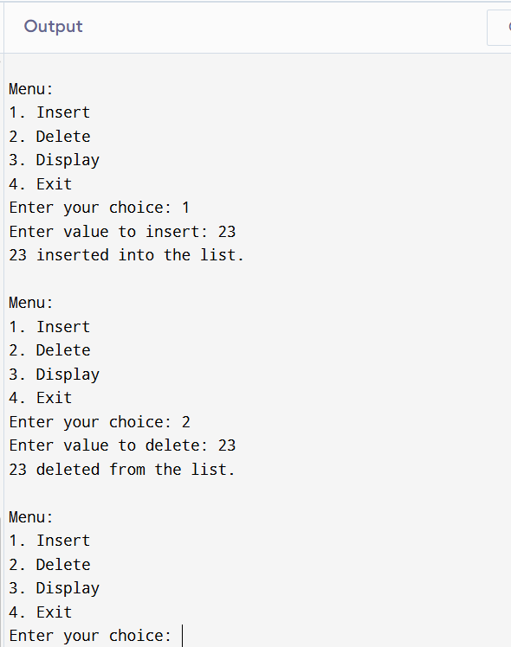

9.Write a program to perform the operations of the Circular linked list:
- Insertion
- Deletion
- Display
#include <stdio.h>
#include <stdlib.h>

// Node structure
struct Node {
int data;
struct Node* next;
};

struct Node* last = NULL; // pointer to last node

// Insert at the end
void insert(int value) {
struct Node* newNode = (struct Node*)malloc(sizeof(struct Node));
newNode->data = value;

if (last == NULL) {
last = newNode;
last->next = last; // circular link
} else {
newNode->next = last->next;
last->next = newNode;
last = newNode;
}
printf("%d inserted into circular linked list.\n", value);
}

// Delete a node by value
void delete(int value) {
if (last == NULL) {
printf("List is empty. Cannot delete.\n");
return;
}

struct Node* curr = last->next;
struct Node* prev = last;

// Traverse until we find the node or come back to start
do {
if (curr->data == value) {
if (curr == last && curr->next == last) {
// Only one node
last = NULL;
} else {
prev->next = curr->next;
if (curr == last) {
last = prev; // update last if deleting last node
}
}
free(curr);
printf("%d deleted from circular linked list.\n", value);
return;
}
prev = curr;
curr = curr->next;
} while (curr != last->next);

printf("%d not found in the list.\n", value);
}

// Display the circular linked list
void display() {
if (last == NULL) {
printf("List is empty.\n");
return;
}
struct Node* temp = last->next;
printf("Circular Linked List: ");
do {
printf("%d -> ", temp->data);
temp = temp->next;
} while (temp != last->next);
printf("(back to start)\n");
}

int main() {
int choice, value;

while (1) {
printf("\nMenu:\n");
printf("1. Insert\n2. Delete\n3. Display\n4. Exit\n");
printf("Enter your choice: ");
scanf("%d", &choice);

switch (choice) {
case 1:
printf("Enter value to insert: ");
scanf("%d", &value);
insert(value);
break;
case 2:
printf("Enter value to delete: ");
scanf("%d", &value);
delete(value);
break;
case 3:
display();
break;
case 4:
return 0;
default:
printf("Invalid choice.\n");
}
}
}

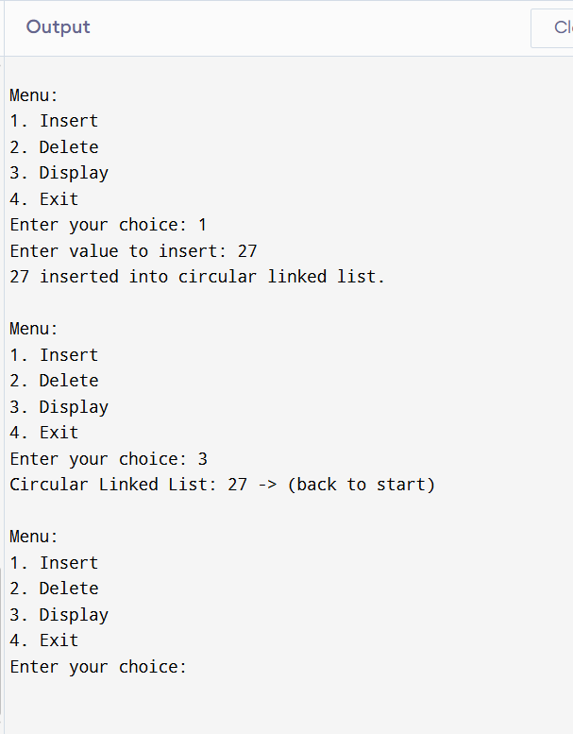

- Write a program to perform all operations: - For Stack using Linked List.
- For Queue using Linked List
- For Circular Queue using Linked List

#include <stdio.h>
#include <stdlib.h>

// ---------- STACK USING LINKED LIST ----------
struct StackNode {
int data;
struct StackNode* next;
};
struct StackNode* top = NULL;

void push(int x) {
struct StackNode* newNode = (struct StackNode*)malloc(sizeof(struct StackNode));
newNode->data = x;
newNode->next = top;
top = newNode;
printf("%d pushed to stack\n", x);
}

void pop() {
if (top == NULL) {
printf("Stack Underflow\n");
return;
}
struct StackNode* temp = top;
printf("%d popped from stack\n", temp->data);
top = top->next;
free(temp);
}

void displayStack() {
if (top == NULL) {
printf("Stack is empty\n");
return;
}
struct StackNode* temp = top;
printf("Stack elements: ");
while (temp != NULL) {
printf("%d ", temp->data);
temp = temp->next;
}
printf("\n");
}

// ---------- QUEUE USING LINKED LIST ----------
struct QueueNode {
int data;
struct QueueNode* next;
};
struct QueueNode* front = NULL;
struct QueueNode* rear = NULL;

void enqueue(int x) {
struct QueueNode* newNode = (struct QueueNode*)malloc(sizeof(struct QueueNode));
newNode->data = x;
newNode->next = NULL;
if (rear == NULL) {
front = rear = newNode;
} else {
rear->next = newNode;
rear = newNode;
}
printf("%d enqueued to queue\n", x);
}

void dequeue() {
if (front == NULL) {
printf("Queue Underflow\n");
return;
}
struct QueueNode* temp = front;
printf("%d dequeued from queue\n", temp->data);
front = front->next;
if (front == NULL) rear = NULL;
free(temp);
}

void displayQueue() {
if (front == NULL) {
printf("Queue is empty\n");
return;
}
struct QueueNode* temp = front;
printf("Queue elements: ");
while (temp != NULL) {
printf("%d ", temp->data);
temp = temp->next;
}
printf("\n");
}

// ---------- CIRCULAR QUEUE USING LINKED LIST ----------
struct CQueueNode {
int data;
struct CQueueNode* next;
};
struct CQueueNode* cfront = NULL;
struct CQueueNode* crear = NULL;

void cenqueue(int x) {
struct CQueueNode* newNode = (struct CQueueNode*)malloc(sizeof(struct CQueueNode));
newNode->data = x;
if (cfront == NULL) {
cfront = crear = newNode;
newNode->next = cfront;
} else {
crear->next = newNode;
crear = newNode;
crear->next = cfront;
}
printf("%d enqueued to circular queue\n", x);
}

void cdequeue() {
if (cfront == NULL) {
printf("Circular Queue Underflow\n");
return;
}
struct CQueueNode* temp = cfront;
printf("%d dequeued from circular queue\n", temp->data);
if (cfront == crear) {
cfront = crear = NULL;
} else {
cfront = cfront->next;
crear->next = cfront;
}
free(temp);
}

void displayCQueue() {
if (cfront == NULL) {
printf("Circular Queue is empty\n");
return;
}
struct CQueueNode* temp = cfront;
printf("Circular Queue elements: ");
do {
printf("%d ", temp->data);
temp = temp->next;
} while (temp != cfront);
printf("\n");
}

// ---------- MAIN ----------
int main() {
int choice, x;
while (1) {
printf("\nMenu:\n");
printf("1. Push (Stack)\n2. Pop (Stack)\n3. Display Stack\n");
printf("4. Enqueue (Queue)\n5. Dequeue (Queue)\n6. Display Queue\n");
printf("7. Enqueue (Circular Queue)\n8. Dequeue (Circular Queue)\n9. Display Circular Queue\n");
printf("10. Exit\n");
printf("Enter choice: ");
scanf("%d", &choice);

switch (choice) {
case 1: printf("Enter value: "); scanf("%d", &x); push(x); break;
case 2: pop(); break;
case 3: displayStack(); break;
case 4: printf("Enter value: "); scanf("%d", &x); enqueue(x); break;
case 5: dequeue(); break;
case 6: displayQueue(); break;
case 7: printf("Enter value: "); scanf("%d", &x); cenqueue(x); break;
case 8: cdequeue(); break;
case 9: displayCQueue(); break;
case 10: return 0;
default: printf("Invalid choice\n");
}
}
}

